Learning Support Policy

Park Lane Learning Support Philosophy

At Park Lane International School we sincerely believe that every young person, irrespective of race, cultural heritage, faith or ability, is entitled to lead a happy, safe and productive life. Through celebrating every student’s individual personality and strengths, we aim to accommodate students who require learning support within the school community. We focus on needs both inside and beyond the classroom to help support the whole individual, not just their academic requirements.

We believe that learning support is a whole school issue and therefore all staff and teachers:
- Have a responsibility to identify a pupil who is seriously underachieving or struggling to access the curriculum, to consult the Learning Support and Inclusion Coordinator (Ioanna Tsouka, Early Years & Primary) or the Head of Inclusion (HoI) - previously titled SENCo - (Kim Holmes, Secondary).
- Have a duty to consult the Learning Support and Inclusion Coordinator (LSIC) or Head of Inclusion to discuss the way forward for a student who has been identified as under-performing or struggling with some aspect of school life, whether social, emotional or academic.
- Have a responsibility (supported by the LSIC or HoI, as appropriate) to plan and provide for the range of abilities in the classroom, using the principles of Universal Design for Learning (UDL), Differentiated Instruction, scaffolding and inclusion so that all children may achieve success and enjoy learning.

Scope of Support at Park Lane

Park Lane is a relatively small international school situated in the centre of historic Prague, with satellite campuses in Prague 6 and Prague 5 for our younger years. We have a total of 660 students at Park Lane across all 6 campuses; 280 in primary (Nursery to Year 6) and 380 in our secondary branch in class sizes of up to 22 students. Having a Support Team allows for each individual to be valued by the school community. It also allows us to bring out the best in each student, to work with them, and their families where appropriate, to plan and monitor academic progress and maximise potential.

Currently, approximately 15% of our students are identified as having additional learning needs, including SEN and EAL, in Secondary. These needs require a whole range of support strategies from observation and monitoring, in-class assistance to one-to-one support in certain areas. These levels of need can be categorised into communication and interaction needs; cognition and learning needs; sensory and / or physical needs, and lastly - where the need affects a student in their learning - social, emotional and mental health difficulties. Otherwise, the latter usually falls under the remit of our pastoral and safeguarding support at Park Lane.

In Primary, around 27% of pupils have additional learning needs. This includes pupils with both EAL and SEN needs who receive additional support. Support for pupils happens within the classroom, as part of an intervention group, or on a 1:1 basis.

Our Norbertov, Sibeliova and Nessie school buildings make up our primary campuses. These sites are split between Prague 5 and Prague 6. The split sites cater for different age groups and the settings are adapted and developed for the needs of pupils in the different age phases. The buildings are not purpose-built as a school and have been adapted and changed to suit the needs of pupils. Similarly to secondary, there are stairs but no lifts. This means that the Primary School sites would not be able to support pupils who are wheelchair users.

Our Valdstejnska school building is a former embassy residence spread over 4 floors with narrow staircases and no lifts. For this reason, we are currently unable to support students who require wheelchair access. In Klarov (our KS4 campus), where our SEND office is also located on the 3rd floor, a lift may provide access to upper floors for students with physical disabilities. In addition, where possible, Park Lane endeavours to support students with learning needs by reducing the IGCSE offering so that they may tackle a smaller number of classes. Our IB Diploma programme based at the Uvoz site in Mala Strana, however, is selective and based upon prior academic achievement. While we follow the IB’s access and inclusion policy, this relates mostly to the availability of access arrangements such as extra time, word processor, reader, rest breaks etc, and it is important to note that examination content cannot be tailored for students.

Finally, our Pohadka site is nestled between the two other Prague 1 campuses and functions mainly as our Art centre, with a cafe area that is open to students, staff and parents of the Park Lane community.

The objectives of the School’s Learning Support Policy

- Early identification: to identify any pupils who require learning support as early as possible.
- To use the school’s assessment procedures for regular monitoring and appraisal of pupils’ performance in order to identify students who are actually or potentially underperforming.
- To ensure that pupils who need extra support have a co-ordinated approach that extends across all subjects and which receives appropriate support from all staff.
- To ensure that pupils who need support have access to improved learning opportunities in order to allow them to maximise their potential.
- To monitor and track pupils' targets and interventions as set out in the relevant sections of the school’s Provision Map programme.

Definition of Learning Difficulty

The school recognises the UK Department for Education, Special educational needs and disability code of practice: 0 to 25 years, definition of Specific Learning Difficulties (Ref: DFE-00205-2013, introduction xiv)

“A child of compulsory school age or a young person has a learning difficulty or disability if they:
• have a significantly greater difficulty in learning than the majority of others of the same age, or
• have a disability which prevents or hinders them from making use of facilities of a kind generally provided for others of the same age in mainstream schools or mainstream post-16 institutions”

At Park Lane International School, a learning difficulty is recognised when the achievement and performance of a pupil, as indicated by a consensus among those who have taught them and supported by standardised and diagnostic tests, is well below what is expected for the individual pupil concerned. In some cases, where diagnostic or psychometric tests have not been previously carried out, a full assessment from an Educational Psychologist or the school’s HoI or LSIC may be recommended to parents.

Referral of Students

Students at Park Lane are identified as having Learning Support needs via one of two routes:
- Information is provided by parents at the time of admission relating to previously identified learning and support needs.
- Class teachers refer students to the Head of Inclusion (HoI) or the team who work in their capacity as learning support teachers or assistants
- CEM data (Select, MidYis, Yellis, IBE) highlights significant areas of concern and the HoI or learning support team carry out observations and request that teachers complete monitoring forms (Appendix 3) or provide descriptive feedback through school robins

After referral and an investigation of data and comments from teachers (through monitoring forms and school robins), students may be placed on the Learning Support Register, which outlines key details (chronological age, reading age, areas of difficulty etc). Depending on the level of need (see Multi-Tiered System of Supports in appendix 1) the SENCo / Head of Inclusion and support staff may complete a Pupil Passport (example in appendix 4) in collaboration with the student. At a higher tier, a student may have a learning plan (appendix 5) with individual goals, some targeted intervention and support. The learning plan is reviewed twice a year (termly in some cases) and usually includes student voice. Parents play a more active role in the learning plan and can comment on their child’s plan in the Provision Map programme. Passports and learning plans also contain information about access arrangements for assessments, in cases where access arrangements have been implemented or recommended. Teachers have access to view pupils' learning plans and passports on the Provision Map platform and can also write in any provisions that they may be running in their subject areas.

External Referrals

Following observation in school and discussion with teachers and parents it may be necessary to refer families to external agencies in order for the student to undergo a pedagogical psychological or cognitive assessment. Many of the psychometric assessments that outline areas of strength or weakness can also be done in school by the HoI / LSIC. These tests can be helpful in building a picture of need and making applications to examination boards. However, due to the cost of the tests themselves, the school charges a small fee for these tests. Reports from such agencies are viewed by the LSIC or HoI, translated where necessary, and important aspects and recommendations summarised and shared with staff. These reports also form the basis for discussion of exam access arrangements and the next passport / provision map review meetings.

Provision Map

According to the SEND Code of Practice (2015), “the provision made for pupils with SEN/D should be recorded accurately and kept up-to-date; schools should particularly record details of additional or different provision made under SEN support which should form part of regular discussions with parents about the child’s progress, expected outcomes from the support and planned next steps; schools should ensure that they have accurate information to evidence the SEN support that has been provided over the pupil’s time in the school, as well as its impact”.

A provision map is a clear and systematic approach of evidencing the various types of support and resources offered to students within our school. It encompasses a wide spectrum of support, ranging from universal, high-quality classroom instruction (quality first teaching), to collaborative targeted group interventions and intensive, highly tailored supports.

At Park Lane International School, we use Provision Map as a comprehensive tool, which helps us to map and manage provisions, interventions, pupil passports and learning plans, school-wide. Over time this allows the school to develop a history of need for each child as they move through the school. Provision map also allows parents to see their child's learning plan, passport and provisions, and gives them the ability to comment on these and communicate with the LSIC and HoI all within the platform.

Examinations (& Exam Access Arrangements)

Park Lane is committed to ensuring that all students are able to perform in examinations at the level of their ability.

We therefore work towards providing students with appropriate Exam Access Arrangements that provide reasonable adjustments and promote positive learning outcomes and fair opportunities for the students’ overall progress, without them being disadvantaged based on their learning profile.

The arrangements given to students in exams are in line with the guidelines issued by the exam boards being studied (e.g. Cambridge International Examinations for KS4, and International Baccalaureate for KS5. We try to follow the JCQ guidelines for KS3 where possible. Any decisions made regarding Exam Access Arrangements are made by the LSIC for primary, and by the HoI for secondary pupils. Reasonable adjustments can be implemented by the HoI in KS3, while psychological / psychometric reports inform the access arrangements allowed at IGCSE and IB. Applications to exam boards are made by the exams Officer and IBDP coordinator, in collaboration with the HoI. These decisions will always be made following communication with parents and the students themselves.

Typical arrangements include but are not limited to; extra time, prompts, use of a word processor, separate examination rooms, reader, scribe and rest breaks. This list is not exhaustive and each student is looked at on an individual basis. Any exam access arrangements that are requested must reflect the student's “usual way of working” in a classroom environment.

Long Term Absence / Illness

When a student is absent for a long period of time it is the responsibility of the Form Tutor and Head of Year (HoY), in liaison with the Head of School, LSIC or HoI, to collaborate with parents and the student themselves.

Depending on the nature of the illness, students may be supported in continuing the curriculum at a pace and situation that is appropriate to them. This could involve teachers preparing tasks and longer-term projects for students to complete, in order to reduce pressure on the student. Teachers and support teams also endeavour to support students via distance learning (e.g. over Zoom) as much as possible, however constraints exist which relate to time on screen, ability for extra time, scribing etc. As all recommendations outlined in psychometric / psychological reports are recommendations only, the school is only obligated to implement these recommendations / accommodations as is appropriate and possible, taking into consideration the teaching and learning of all students involved.

When the time comes for the student to return to school, the Form Tutor and HoY, in collaboration with support teams will work with the student to establish core lessons to focus on and then work to include the rest of the curriculum. In all circumstances, whether the students are on distance learning, in school on a reduced programme, or back full time, teachers should endeavour to differentiate appropriately and seek support from the pastoral team and HoI / LSIC where necessary.

Roles and Responsibilities within the School

Senior Leadership Team
The Board of Management has an important role in developing, supporting and monitoring school policy on learning support and additional learning needs. The Senior Leadership Team should:
- Oversee the development, implementation and review of school policy on learning support services in general.
- Ensure that adequate classroom accommodation and teaching resources are provided for the learning-support teacher.
- Ensure that the LSIC and HoI has the capacity (time, facilities, equipment, training etc) to fulfil their role.
- Foster a positive attitude towards inclusion and inclusive teaching across the whole school from all staff. This should include students with different cultural backgrounds.
- Actively promote and support diversity, equity and inclusion
- Ensure time is made available for the LSIC and HoI to do staff training and feedback on students, learning needs and appropriate differentiation and UDL strategies

Parents
Parents have a dual function in Learning Support:
1) in supporting the school and
2) in communicating with the school.

- Supporting the School
- Be involved in creating a positive attitude towards school.
- Be involved with Learning Plans by adding parent comments to the Provision Map by EduKey
- Requesting communication with the LSIC and HoI / Support Assistants and participating with students in their educational activities.

2. Communicating with school;
- Discuss results of any pre-existing diagnostic assessment with LSIC / HoI.
- Inform the school of any learning difficulties / additional learning needs observed at home (also applies to the progress of the student)
- Meet with Learning Support staff and class teacher regularly to discuss specific targets / activities if support is to be continued or discuss how future learning needs can be met at home if learning support is to be discontinued.
- Maintain regular contact with school through parent-teacher meetings and through any other information sessions organised by the school. Email, Zoom, and telephonic communication is also encouraged.
- Use the Provision Map to view, review and add parent comments regarding their child’s learning needs.

Inclusion

Inclusive education promotes inclusive societies, where people can live together and diversity is celebrated. Inclusion in education involves:
- valuing all students and staff equally.
- increasing the participation of students in, and reducing their exclusion from, the cultures, curricula and communities of schools.
- reducing barriers to learning for all students, not only those with additional needs or those categorised as having ‘special educational needs’.
- At Park Lane, we create a positive learning environment where all students are welcome and encouraged, regardless of learning need or cultural background.

Form Tutors / Class Teachers/Subject Teachers

- In the primary age phase pupils are taught as part of a class group and their learning is supported by a class teacher and teacher partner in lessons. Within the classroom pupils are taught through quality first teaching known as QFT or Wave 1.
- If pupils need additional support they may have interventions as part of a small group or 1:1. This is known as Wave 2 support.
- After further assessments from external agencies or long term interventions, pupils will have a Learning Passport and this is written with staff, parents and pupils. This is Wave 3.
- In the secondary school, there is also an emphasis on the idea that all teachers are teachers of SEND.
- There is an expectation for all teachers to intentionally plan for the progress of all pupils and therefore high quality teaching alongside the implementation of differentiation strategies is the first stage of support.
- Students with learning difficulties are integrated into regular classes at all times. Withdrawal from a subject or from some classes may be deemed appropriate by the HoI / LSIC only when it is of benefit to the student.
- Staff members are encouraged to read, understand and apply the provisions and plans outlined in the students’ Provision Map.
- Staff members help students to engage with their learning plan by supporting and implementing all relevant and appropriate accommodations.
- Learning support staff in charge of relevant portfolios (e.g. dyslexia support teacher) will work on developing strategies for children who fit their remit and will share these strategies with teachers. At all times portfolio leads should be in communication with and answerable to the HoI.
- Teachers should aim to foster students' positive regard, motivation for learning, and self-esteem by giving genuine praise whenever possible and promoting activities which yield success.
- If a student is put on a learning plan or a provision map is created, the teacher will be required to give feedback to the LSIC / HoI prior to any review meeting.
- At all stages, pupils should be involved with their learning passports and any targets which are set out in the learning plan.
- Teachers who are implementing additional support should write these up in the students’ provision map in order that progress can be tracked

Goals of the HoI / SENCo (Secondary) and LSIC (Primary)

- To help create a positive learning environment where all students are welcomed and encouraged, regardless of learning need or cultural background.
- To support teaching staff in identifying children with special educational needs (SEN).
- To conduct classroom observations of pupils identified as being potential candidates for learning support and pupils already receiving learning support.
- To maintain a current register of learning and support needs.
- To support staff in the identification of the most effective teaching approaches for children with specific learning needs and monitor teaching and learning activities.
- To provide training and information on effective differentiation and inclusion strategies in relation to learning support.
- To provide training for teachers on the various learning disabilities and the effects of these learning differences in the classroom. At Park Lane these generally include mild learning difficulties such as difficulties with reading, writing, spelling or mathematical calculations. A smaller but significant proportion may also have a diagnosed specific learning difficulty (SpLD) like dyslexia dyscalculia, dyspraxia etc.
- To conduct learning walks and provide whole school feedback.
- To develop provision maps in partnership with teachers and parents/caregivers.
- To organise follow up meetings to review pupils' passports and learning plans (at least twice per year in line with the Czech ministry of education guidelines for children with SEN and / or psychological reports).
- To oversee the records of and monitor the progress of children receiving additional support.
- To maintain safe record keeping and keep confidential reports in a locked office.
- To feed back to key staff regarding the progress of pupils receiving Learning Support.
- To develop links with and liaise with external agencies.
- To be aware of and maintain up-to-date information regarding exam Access Arrangements and exam board requirements. This information will be shared with class teachers, the Exams Officer and the IB coordinator.

Review

The Learning Support Policy should be reviewed annually by the HoI and LSIC in collaboration with colleagues from the senior leadership team.

Appendix 1 – Multi-Tiered System of Supports (MTSS)

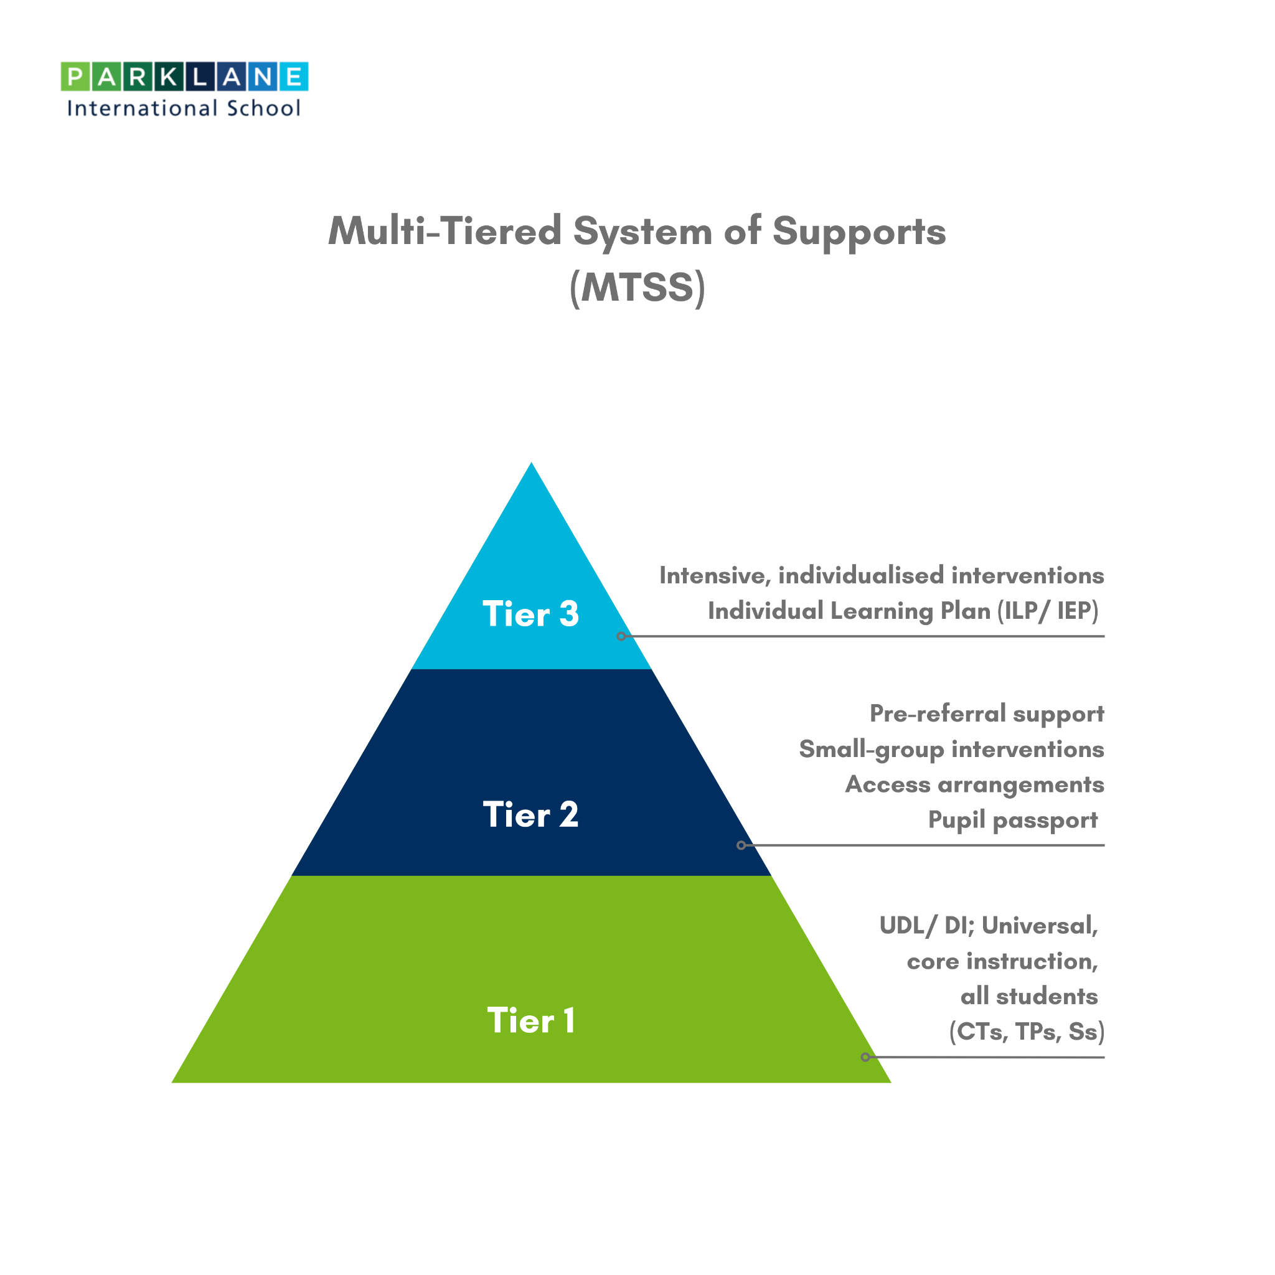

Appendix 2 – SEND/ Learning Support Stages of Action

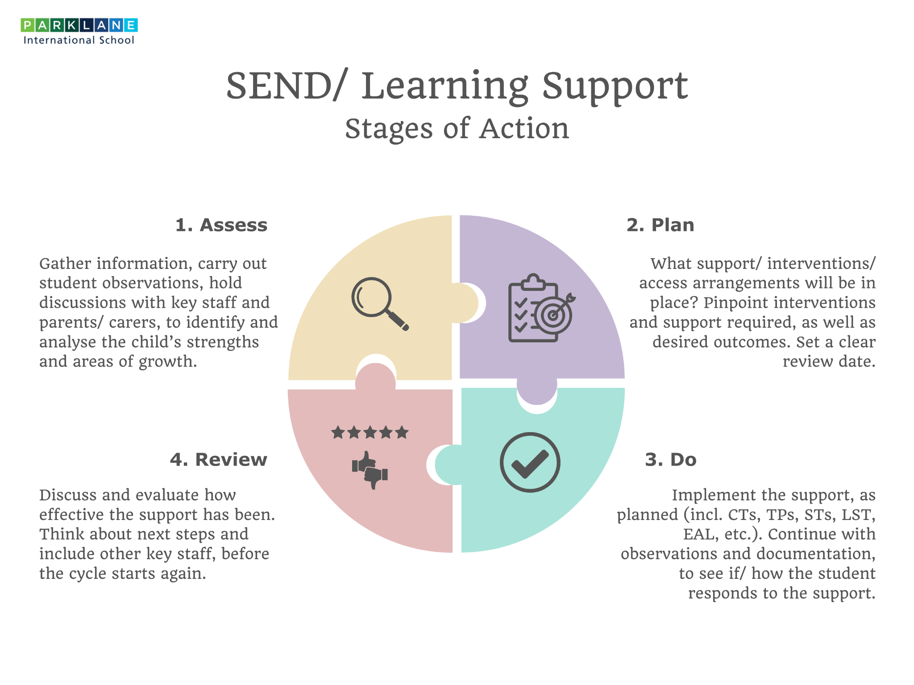

Appendix 3 – Monitoring Form
 |  | Please use X to indicate answer.
Additional Needs |  | No concerns | Requires  occasional support | Requires  continuous support | Not  applicable
Concentration: Staying on task, ignoring distractions, focusing on the teacher, remembering instructions etc.
Organisational Skills: Physical organisation of self and equipment, planning ahead with work, thinking about consequences before actions etc.
Speech and Language: Understanding their first spoken language, acquiring new vocabulary, ability to express themselves clearly in sentences etc.
English / Literacy | Reading: Ability to read a paragraph or more with ease and fluency.
 | Spelling: Ability to consistently spell common words and make a good attempt at unfamiliar words.
 | Extended Writing: Ability to write a correctly punctuated paragraph or more with ease and fluency.
 | Handwriting: Ability to write legibly, with ease and at a pace equivalent to peers.
English as Additional Language: Understanding English as a second language, acquiring new vocab etc.
Numeracy/Maths: Demonstrating a basic grasp of number, algebra, data, shape / space and measure etc.
Physical/Hearing/Visual: Ability to access all activities despite physical, hearing or visual difficulty etc.
Social: Forming and maintaining positive relationships, conforming to social norms etc.
Emotional: Showing awareness of own feelings and that of others, managing feelings, confidence etc.
Homework/Coursework: Ability to study independently, to produce work to deadlines etc.
Exams: Ability to prepare for and sit an exam without close adult support.

Overall, how well is this student progressing in your lesson/s? (please include current attainment levels / GCSE targets where possible)

Appendix 4 – Example student passport
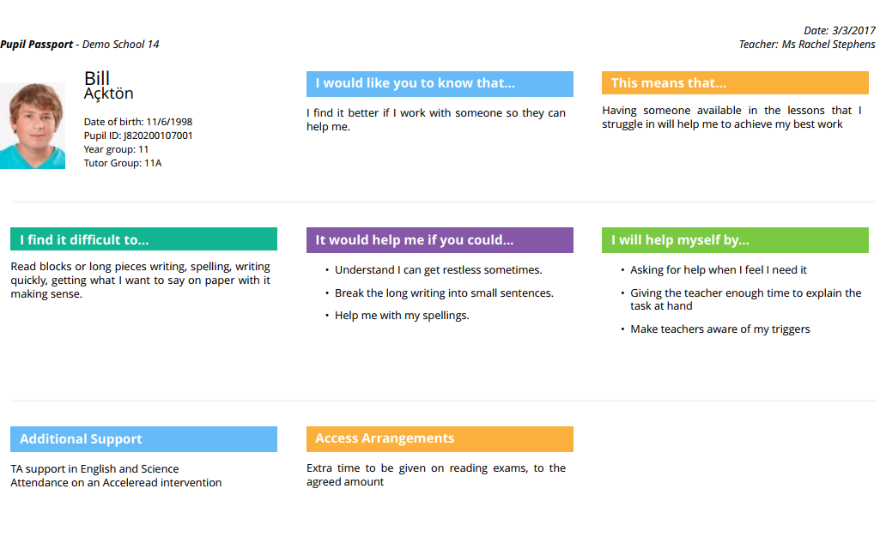

Appendix 5 – Example Learning Plan

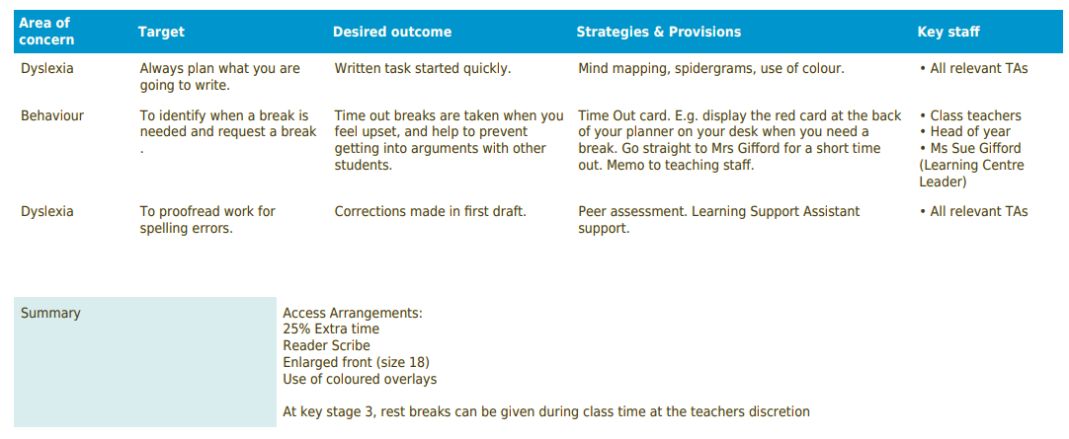

Appendix – Mission Statement

